**Course Code: CSE2067**

**Course Title: Web Technologies**

**Lab sheet 6 - Module 2**

**Problem Statement:**

Mr. Arun Student of Presidency University wants to create an attractive web page for Presidency University using HTML and CSS with following specifications.

* Split the web page into two parts using frames, top section 20% and bottom section 80%.
* Place your college logo at the top of the page with menu’s (About, Academic, Admission, Facilities, etc). Create hyperlink for all menus.
* Create a web page about the college linked at the bottom of the frame.
* Create a web page about the Academic linked at the bottom of the frame.
* Create a web page about the admission, list out the departments, click any deportment name that connects to the registration page and apply the position concept in CSS.
* Create a web page about the Facilities, list out the college facilities and display the images using floating concepts in CSS.
* Create a web page about the login page linked at the bottom of the frame.

***Solution***

**Home.html**

frameset rows="25%,*">

    <frame src="top.html" name="top">

    <frame src="bottom.html" noresize name="bottom" >

    </frameset>

    </frameset>

**Top.html**

 <html>

    <head>

        <link rel="stylesheet" href="mystyle.css">

        <style>

            *    {

        margin:0;

        padding:0;

        box-sizing: border-box;

    }

    body{

        display: flex;

        justify-content: center;

        align-items: center;

        height: 100vh;

        background-color: #151925;

        font-family: sans-serif;

        font-weight: bold;

    }

    a

    {

        position: relative;

        display: inline-block;

        padding:25px 15px;

        margin:20px 10px;

        color: #03e9f4;

        text-decoration: none;

        text-transform: uppercase;

        transition: 0.9s;

        /* letter-spacing: 2px; */

        overflow: hidden;

        margin-right:20px;

    }

    a:hover

    {

        background: #03e9f4;

        color: #050801;

        box-shadow: 0 0 5px #03e9f4, 0 0 25px #03e9f4, 0 0 50px #03e9f4, 0 0 200px #03e9f4;

        -webkit-box-reflect:below 1px linear-gradient(transparent, #0005);

    }

    a:nth-child(1)

    {

        filter:hue-rotate(270deg);

    }

    a:nth-child(2)

    {

        filter:hue-rotate(110deg);

    }

    a:nth-child(3)

    {

        filter:hue-rotate(200deg);

    }

    a:nth-child(4)

    {

        filter:hue-rotate(270deg);

    }

    a:nth-child(5)

    {

        filter:hue-rotate(110deg);

    }

    a:nth-child(6)

    {

        filter:hue-rotate(186deg);

    }

    a span

    {

        position: absolute;

        display:block;

    }

    a span:nth-child(1)

    {

        top:0;

        left:0;

        width:100%;

        height:2px;

        background: linear-gradient(90deg, transparent,#03e9f4);

        animation: animate1 1s linear infinite;

    }

    @keyframes animate1

    {

        0%{left:-100%;}

        50%,100%{left:100%;}

    }

    a span:nth-child(2)

    {

        top:-100%;

        right:0;

        width:2px;

        height:100%;

        background: linear-gradient(180deg, transparent,#03e9f4);

        animation: animate2 1s linear infinite;

        animation-delay: 0.25s;

    }

    @keyframes animate2

    {

        0%{top:-100%}

        50%, 100%{top:100%;}

    }

    a span:nth-child(3)

    {

        bottom:0;

        right:0;

        width:100%;

        height:2px;

        background: linear-gradient(270deg, transparent,#03e9f4);

        animation: animate3 1s linear infinite;

        animation-delay: 0.5s;

    }

    @keyframes animate3

    {

        0%{right:-100%}

        50%, 100%{right:100%;}

    }

    a span:nth-child(4)

    {

        bottom:-100%;

        left:0;

        width:2px;

        height:100%;

        background: linear-gradient(360deg, transparent,#03e9f4);

        animation: animate4 1s linear infinite;

        animation-delay: 0.75s;

        /* border-radius:20px; */

    }

    @keyframes animate4

    {

        0%{bottom:-100%}

        50%, 100%{bottom:100%;}

    }

    </style>

    </head>

    <body>

        <img src="pulogo.png" alt="PU Logo" style="background-color:white; padding:10px;border-radius: 10px; margin-top: 5px;margin-bottom: 5px; height:100px; border:3px solid lightgrey">

        <a href="about.html" target="bottom">

            Home<span></span>

            <span></span>

            <span></span>

            <span></span>

        </a>

        <a href="academics.html" target="bottom">

            <span></span>

            <span></span>

            <span></span>

            <span></span>

            Academic

        </a>

        <a href="admission.html" target="bottom">

            <span></span>

            <span></span>

            <span></span>

            <span></span>

            Admissions

        </a>

        <a href="facilities.html" target="bottom">

            <span></span>

            <span></span>

            <span></span>

            <span></span>

            Facilities

        </a>

        <a href="login.html" target="bottom">

            <span></span>

            <span></span>

            <span></span>

            <span></span>

            Login

        </a>

        <a href="Register.html" target="bottom">

            <span></span>

            <span></span>

            <span></span>

            <span></span>

            Register

        </a>

    </body>

</html>

**About.html**

<html>

    <head>

        <style>

            body

            {

                background-color: rgb(193, 193, 189);

            }

        </style>

    </head>

<body>

    <h1>   Over View</h1>

    <p><b> About the University</p>

    <img src="pu.jpg">

</body>

</html>

**Academics.html**

<html>

<body>

    <h1 style="text-align:center">   WELCOME<br> TO <br>PRESIDENCY UNIVERSITY

</h1>

    </body>

</html>

**Admission.html**

<html>

<head>

    <link rel="stylesheet" href="mystyle.css">

    <style>

        body

        {

            background-color: rgba(189, 189, 188, 0.79);

        }

        .static

        {

        position:sticky;

        top:0;

        right:0;

        display: inline;

        float: right;

        font-size:25px;

        border-radius: 15px;

        padding:10px;

        background-color: aliceblue;

        box-shadow: 0 0 25px black;

        }

        li

        {

            list-style: none;

            margin:8px 5px;

        }

        a

        {

            text-decoration: none;

            color:rgb(50, 53, 51);

        }

        li:hover

        {

            border:2px solid black;

            display:inline-block;

            padding:8px;

            color: azure;

            border-radius: 20px;

            background-color:rgb(37, 38, 43);

        }

        h1

        {

            /* border:2px solid black; */

            display: inline-block;

            padding:5px;

            color:darkslateblue;

            text-shadow: 2px 1px 2px rgb(120, 127, 131);

        }

    </style>

</head>

<body>

    <div class="static">

        <a href="register.html"> For Admission Click Here</a></div>

<h1 >Admissions Open </h1>

<ul>

  <a href="register.html"><li>School of Engineering</li></a>

  <a href="register.html"><li>School of Law</li></a>

  <a href="register.html"><li>School of Management</li></a>

 <a href="register.html"><li>School of Commerce</li></a>

 <a href="register.html"><li>School of Design</li></a>

</ul>

</body>

</html>

**Facilities.html**

<html>

  <head>

    <title>Facilities</title>

    <style>

    body

    {

      background-color: rgb(211, 215, 211);

    }

    img

    {

      float:right;

      height:200px;

      width:350px;

      border-radius: 20px;

      margin:110px 19px;

    }

    p

    {

      margin:29px 23px;

      font-size: 24px;

      width:750px;

      text-align: justify;

    }

    h1

    {

      font-family:'Courier New', Courier, monospace;

      font-size:30px;

      margin:25px 203px;

      border:2px solid black;

      display: inline-block;

      padding:5px;

      border-radius: 15px;

      background-color: lightgray;

    }

    #a2

    {

      float: left;

      margin:160px 10px;

    }

    #P2

    {

      /* border:2px solid black; */

      margin:10px 370px;

      width:650px;

    }

    #h2

    {

      margin:10px 10px;

    }

    </style>

  </head>

  <body>

    <img src="Library.jpg" alt="Library" class="image" id="a1">

    <h1>Library</h1>

  <p>

    The Presidency University reference and lending library is well-stocked with a vast collection of books, reports, journals and periodicals. The library also provides access to the best of business and management-related digital resources through its subscription to various databases consisting of scholarly and industry-relevant content. Students utilize these services for their classroom-related work and for further research into their areas of interest.

  </p>

  <img src="classroom.jpg" alt="Library" class="image" id="a2">

  <h1 #id="H2">Classrooms</h1>

  <p id="P2">

    The Presidency University reference and lending library is well-stocked with a vast collection of books, reports, journals and periodicals. The library also provides access to the best of business and management-related digital resources through its subscription to various databases consisting of scholarly and industry-relevant content. Students utilize these services for their classroom-related work and for further research into their areas of interest.

   </p>

    <img src="Library.jpg" alt="Library" class="image" id="a1">

    <h1>Library</h1>

  <p>

    The Presidency University reference and lending library is well-stocked with a vast collection of books, reports, journals and periodicals. The library also provides access to the best of business and management-related digital resources through its subscription to various databases consisting of scholarly and industry-relevant content. Students utilize these services for their classroom-related work and for further research into their areas of interest.

  </p>

  <img src="classroom.jpg" alt="Library" class="image" id="a2">

  <h1 #id="H2">Classrooms</h1>

  <p id="P2">

    The Presidency University reference and lending library is well-stocked with a vast collection of books, reports, journals and periodicals. The library also provides access to the best of business and management-related digital resources through its subscription to various databases consisting of scholarly and industry-relevant content. Students utilize these services for their classroom-related work and for further research into their areas of interest.

   </p>

</body>

</html>

**Login.html**

<html>

<head>

    <title>Login_Page</title>

</head>

<body>

            <h1 >

                Login Page - // code here

            </h1>

</body>

</html>

**Registration .html**

<html>

<head>

    <title>Login_Page</title>

</head>

<body>

            <h1 >

               Registration Page - // code here

            </h1>

</body>

</html>

**Output:**

Home page:

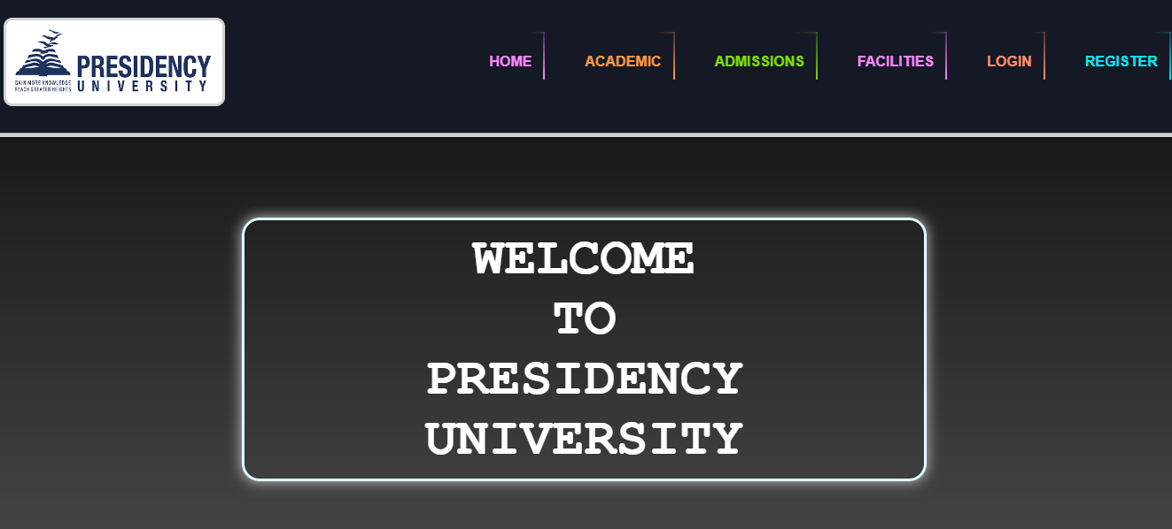

Admission page



Facilities Page

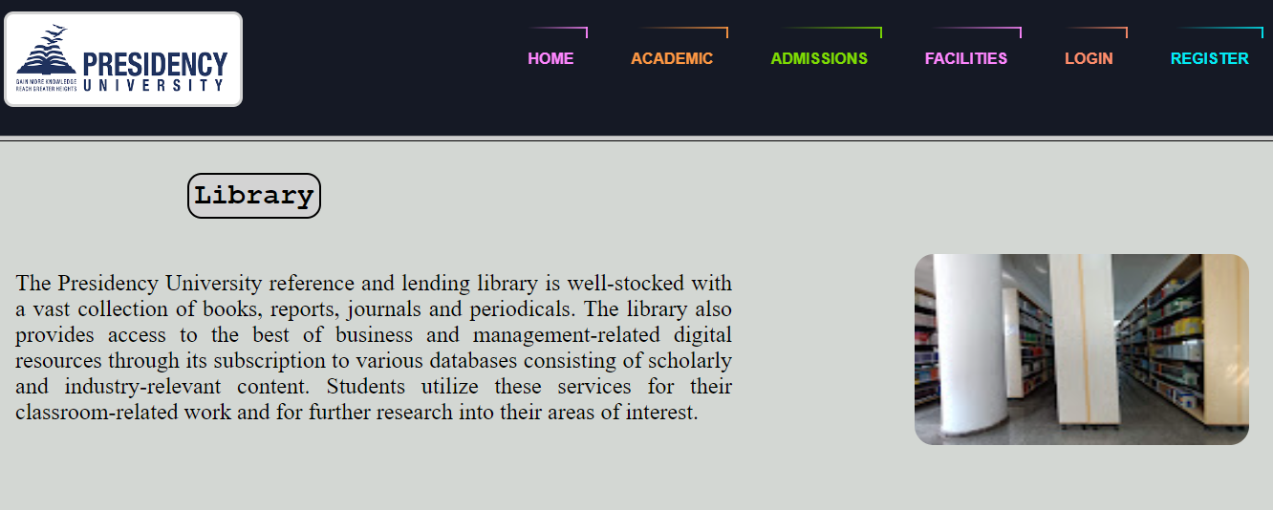

Login page

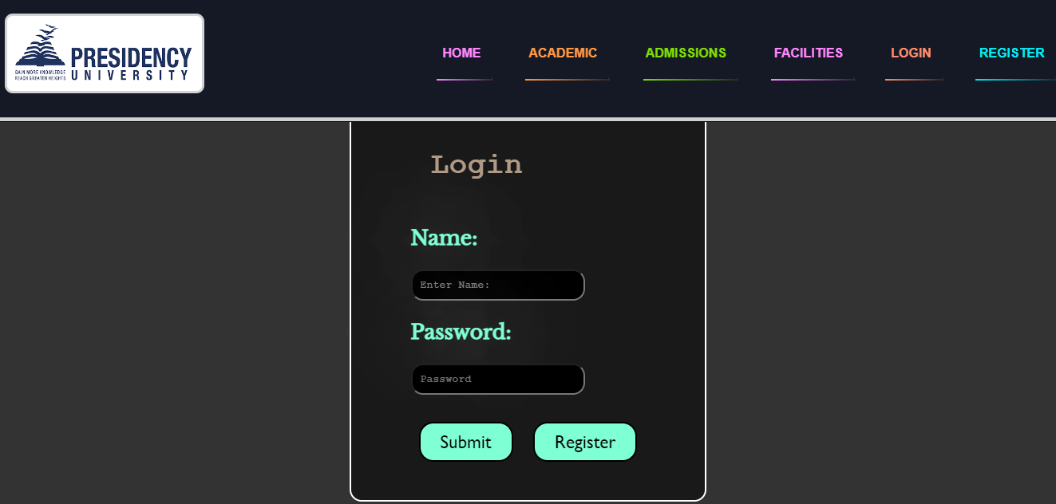

Registration page

